
NAME:

11AEMAM Test 4 2021

Section 1: /

Section 2: /

Total: /

%

TIME ALLOCATION FOR THIS TEST

Section 1 – No Calculators Allowed

minutes reading time: 2 minutes
minutes working time: 30 minutes

Section 2 – Calculators allowed

minutes reading time: 1 minutes
minutes working time: 22

Material required/recommended for this test

To be provided by the supervisor
Question/answer booklets for Sections One and Two.
SCSA 11AEMAM Formulae Sheet

To be provided by the candidate

Section One:

Standard items: pens, pencils, pencil sharpener, highlighter, eraser, ruler
Special materials: drawing instruments, templates, notes on a maximum of one unfolded sheet of A4 paper

Section Two:

Standard items: pens, pencils, pencil sharpener, highlighter, eraser, ruler
Special materials: drawing instruments, templates, notes on a maximum of one unfolded sheet of A4 paper, notes on a maximum of one unfolded sheet of A4 paper, up to three approved calculators, CAS, graphics, or scientific.

Important note to candidates

No other items may be taken into the test room. It is your responsibility to ensure that you do not have any unauthorised notes or other items of a non-personal nature in the test room. If you have any unauthorised material with you, hand it to the teacher before reading any further.

Section | Reading Time | Working time | Marks | Score
Resource free | 2 minutes | 30 | 27 | %
Resource rich | 1 minutes | 20 | 21 | %
Total | 3 minutes | 50 | 49 | %
Resource Free: 30 minutes

Question 1 (6 marks)
(a) On the axes below, sketch the graph of $y^{2}=x$, labelling all key features with their coordinates or equations (3 marks)

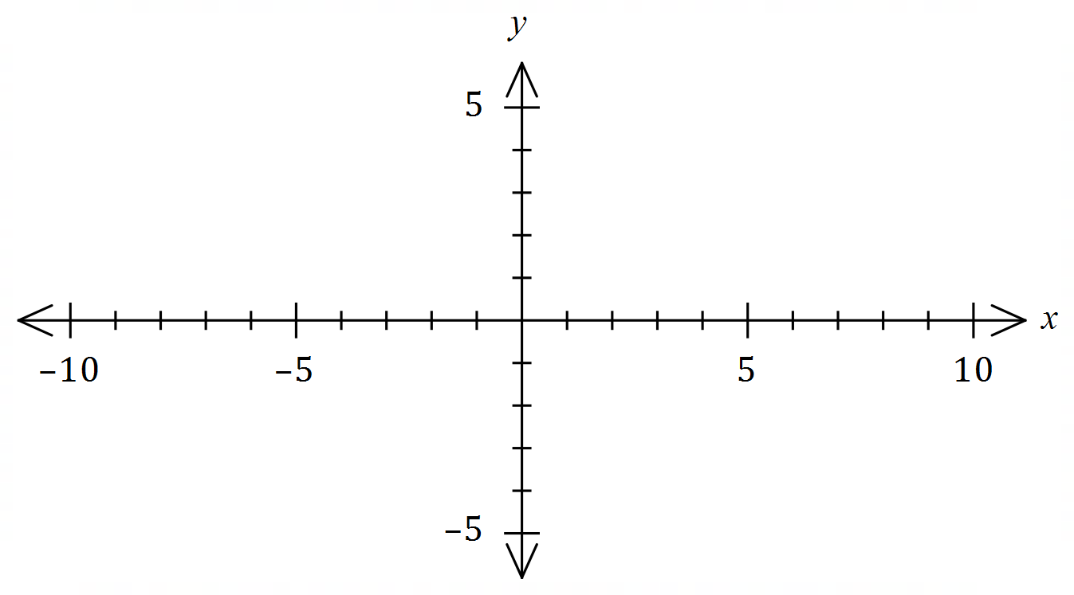

(b) Determine the equation of the circle shown below (3 marks)
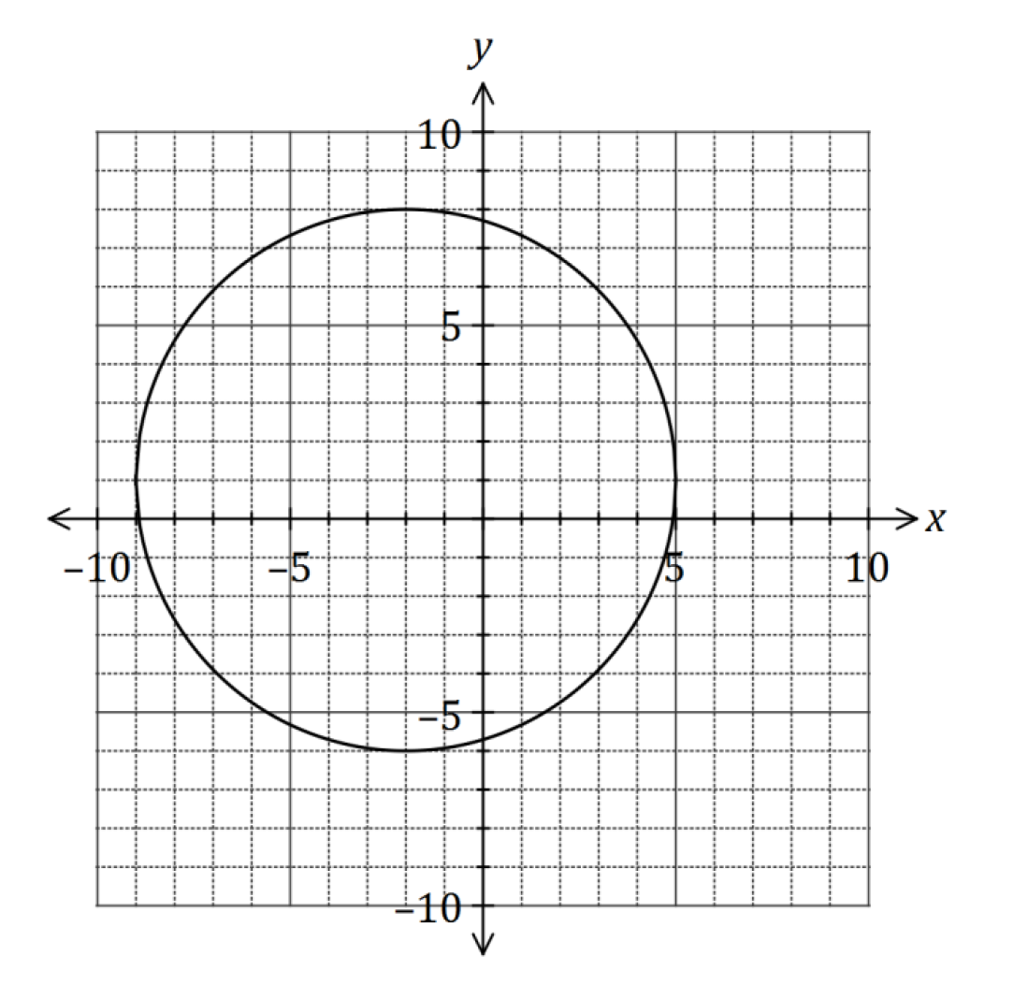

Question 2 (8 marks)
(a) Solve the equation $x^{3}=7x^{2}+30x$ (4 marks)

(b) The graph of $y=ax^{3}+bx+cx+d$ is shown below. Determine the values of the constants of $a, b, c,$ and $d$. (4 marks)
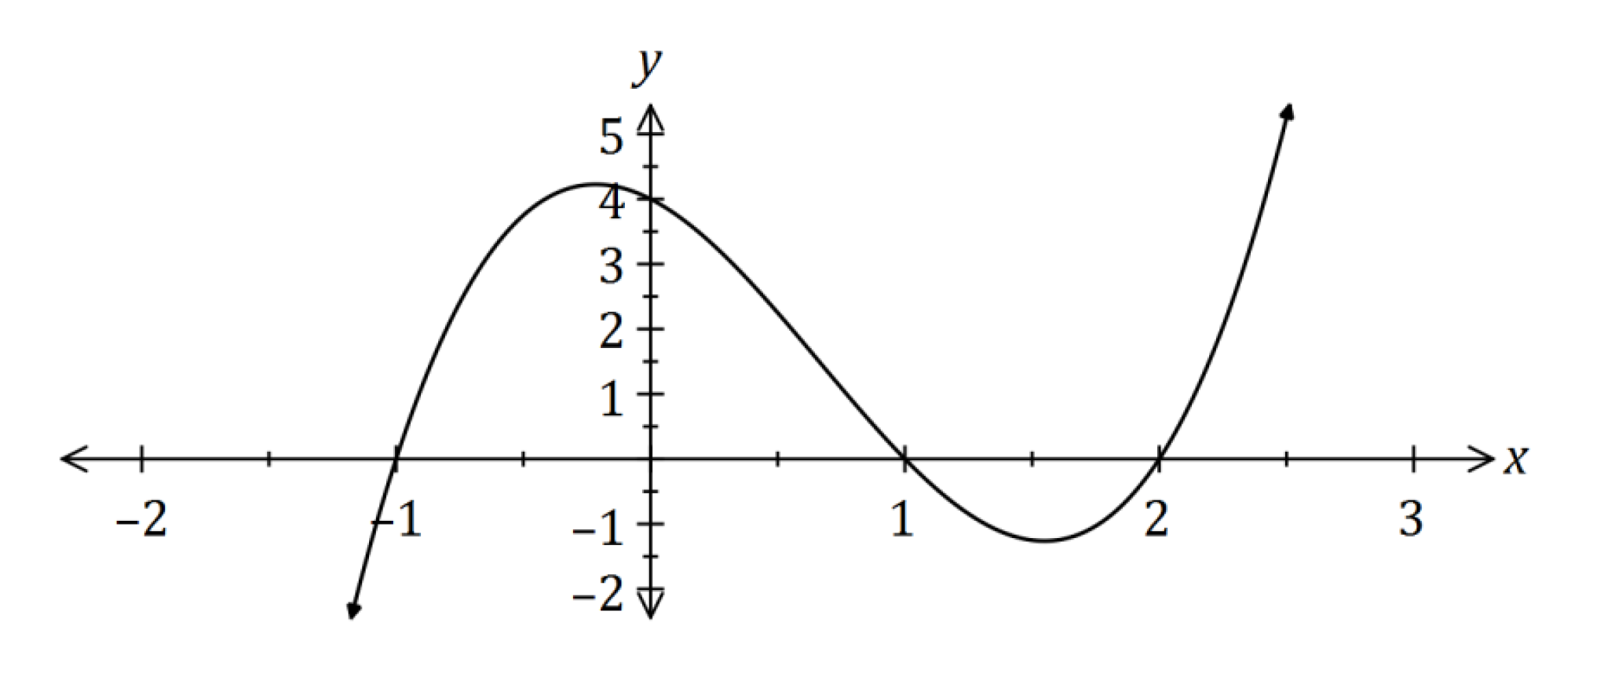

Question 3 (8 marks)
(a) If $α$ and $β$ are acute angles such that $\cos{α=\frac{2}{3}}$ and $\sin{β=\frac{3}{5}}$, determine the value of $\cos{(α-β)}$ as a single fraction. (4 marks)

(b) Solve the following equations.
(i) $\sqrt{2}\sin{x=-1}$ where $0≤x≤2π$ (2 marks)

(ii) $\tan\left(2x\right)=0.4$ where $0≤x≤180°$ given that $\tan{22°}=0.4$ (2 marks)

Question 4 (5 marks)
(a) Find the exact value of $\cos{\frac{13π}{12}}$

END OF SECTION ONE
Calculator Allowed Section Name: …………………………………
Reading time: 1 minutes
Working time: 20 minutes Marks: 21
Question 5 (6 marks)
(a) The graphs of $y=a sin{(x)}, y=\sin{(bx)}, y=d\cos{(x)}$ and $y=\cos{(ex)}$ are shown below.
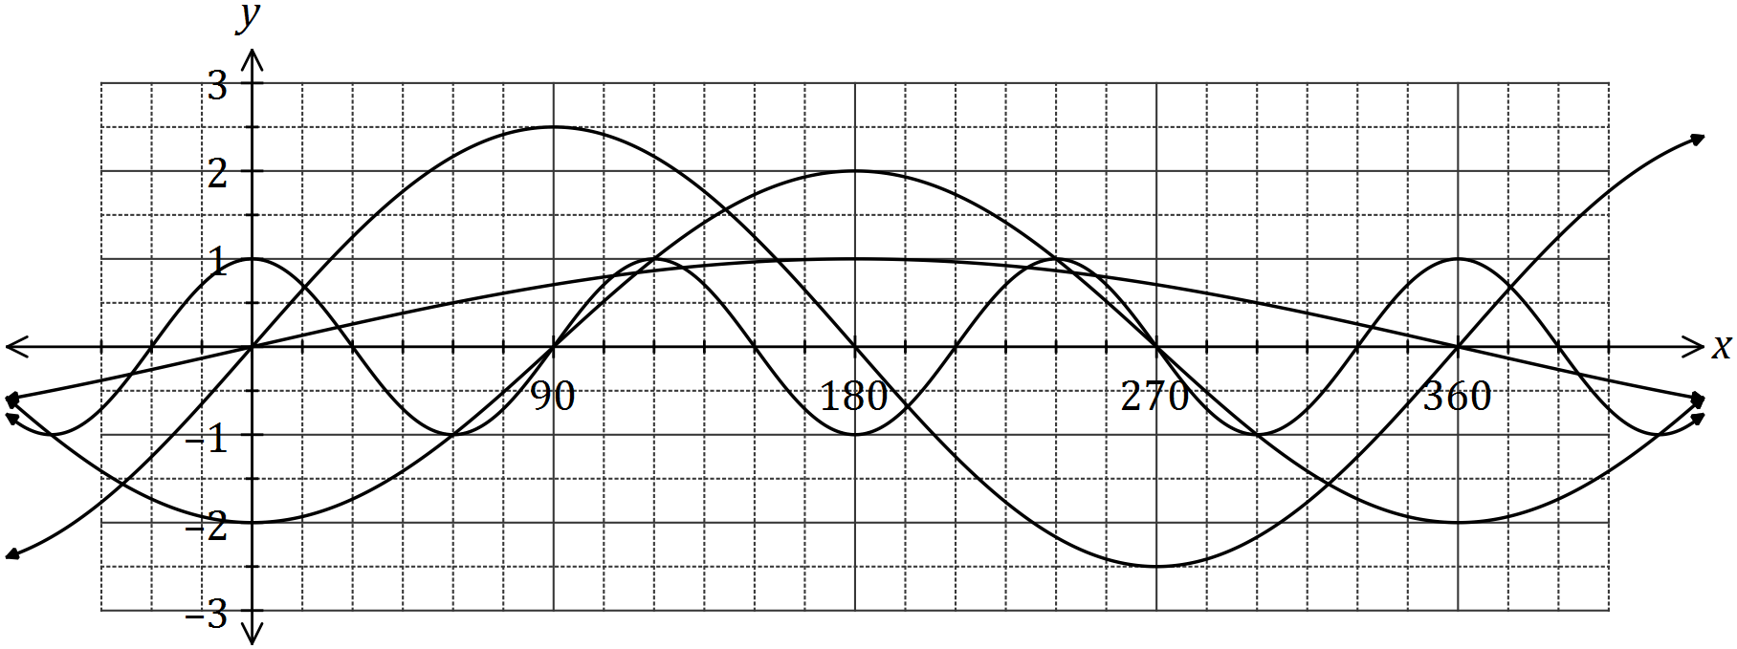
Determine the values of the constants $a, b, d$ and $e$. (4 marks)

(b) The graph of $y=\cos{(x-α)}$ is drawn below.

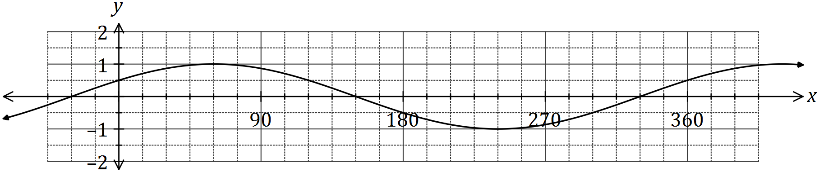

- State the value of the constant $α$, where $0°<α<360°$. (1 mark)

(ii) The graph is also that of $y=\sin{(x+β)}$. State the value of the constant $β$, where
$0°<β<360°$. (1 mark)

Question 6 (7 marks)
Let $f\left(x\right)=\begin{matrix}4 \\ \overline{3-x}\end{matrix}$ and $g\left(x\right)=\begin{matrix}1 \\ \overline{x+p}\end{matrix}+q$, where $p$ and $q$ are constants.

The graph of $y=g(x)$ is shown below.

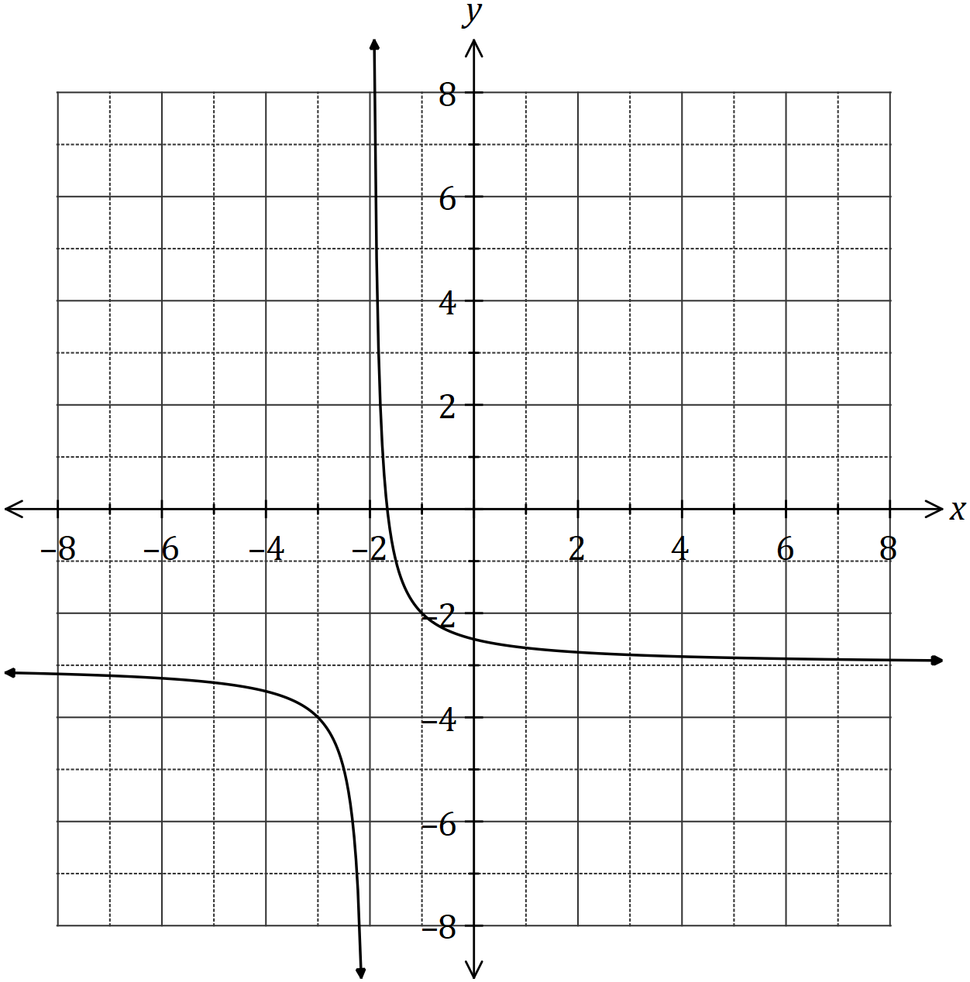

(a) Sketch the graph of $y=f(x)$ on the axes above. (3 marks)

(b) Determine the values of $p$ and $q$. (2 marks)

(c) Solve the equation $f\left(x\right)=g(x)$, giving your solution(s) to one decimal place. (2 marks)

Question 7 (8 marks)
During 2018, the altitude of the sun, $θ$ degrees, at noon in Melbourne on the $n^{th}$ day of the year can be modelled by the equation

$$θ=23.5\sin\left(\frac{8π\left(101+n\right)}{1461}\right)+52.2$$

(a) On the 26th of January, the altitude was $71.4°$. Calculate the altitude ten days earlier.
(2 marks)

(b) Graph the altitude on the axes below for $0≤n≤365$. (4 marks)

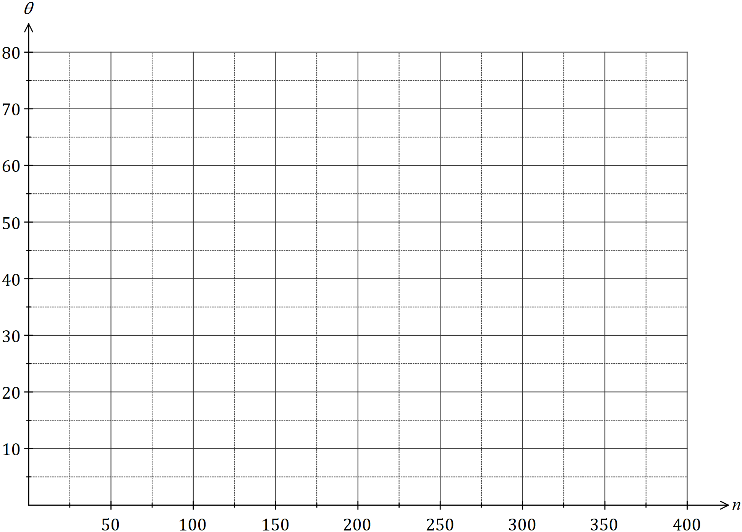

(c) State the minimum altitude of the sun at noon in Melbourne and on which day of the year this occurred. (2 marks)

THIS PAGE HAS BEEN LEFT BLANK INTENTIONALLY TO PROVIDE SPACE FOR WORKING IF REQUIRED
END OF TEST

